Insurance Broker Management System Report

1. Project Description

Overview  
The Insurance Broker Management System (IBMS) is designed for insurance brokers to manage essential business functions, including managing customer data, handling insurance policies, and processing claims. The system aims to streamline operations, allowing brokers to efficiently track customer information, policy details, and claim statuses in a single application.

Features  
The IBMS provides the following core functionalities:

* Customer Management: Create, update, view, and delete customer records.
* Policy Management: Manage insurance policies, including adding, updating, and viewing policy details.
* Claims Management: Submit, update, approve, and reject claims, with each claim's status easily accessible.
* Reporting: Summarize and report key metrics, such as customer counts, total policies, and claim approval/rejection rates.
* Thread-Safe Operations: Ensure safe concurrent access for multiple brokers working simultaneously.

Technologies Used:

* Frontend: HTML, CSS, JavaScript, Tailwind CSS
* Backend: Java Servlets, JSP
* Database: MySQL with Hibernate ORM
* Architecture: J2EE Web Application Architecture
* Design Patterns: Repository Design Pattern, MVC (Model-View-Controller)

System Structure  
This project is structured as a three-tier J2EE Web Application, utilizing:

* Servlet Layer: Handles HTTP requests, directs them to appropriate services, and manages user interactions.
* Service Layer: Contains business logic for handling data and policy-related operations.
* Repository Layer: Manages data storage and retrieval from file-based systems using XML or JSON.

2. Design Decisions

Architecture  
We have adopted a modular J2EE web application architecture with three distinct layers:

* Servlets manage client requests, making the system accessible via a web interface.
* Services encapsulate business logic, ensuring separation of concerns by abstracting operations away from the repository layer.
* Repositories perform CRUD operations on XML or JSON files, handling all file-based persistence and enabling flexible data storage.

File Storage Format (XML/JSON)  
Data persistence is file-based, stored in XML or JSON. Our choice of file format is based on:

* JSON for simpler data structures, lightweight parsing, and quick read/write operations.
* XML for data requiring complex hierarchy or structured metadata.  
  Both formats allow flexibility and ease of implementation, ensuring straightforward file manipulation and data retrieval for the IBMS.

Repository Design Pattern  
The Repository Pattern is used to abstract file-based CRUD operations. Each entity (e.g., Customer, Policy, Claim) has its repository interface and implementation, handling file I/O operations independently of other application layers. This pattern enhances modularity, simplifies testing, and allows easy scalability.

3. Screenshots

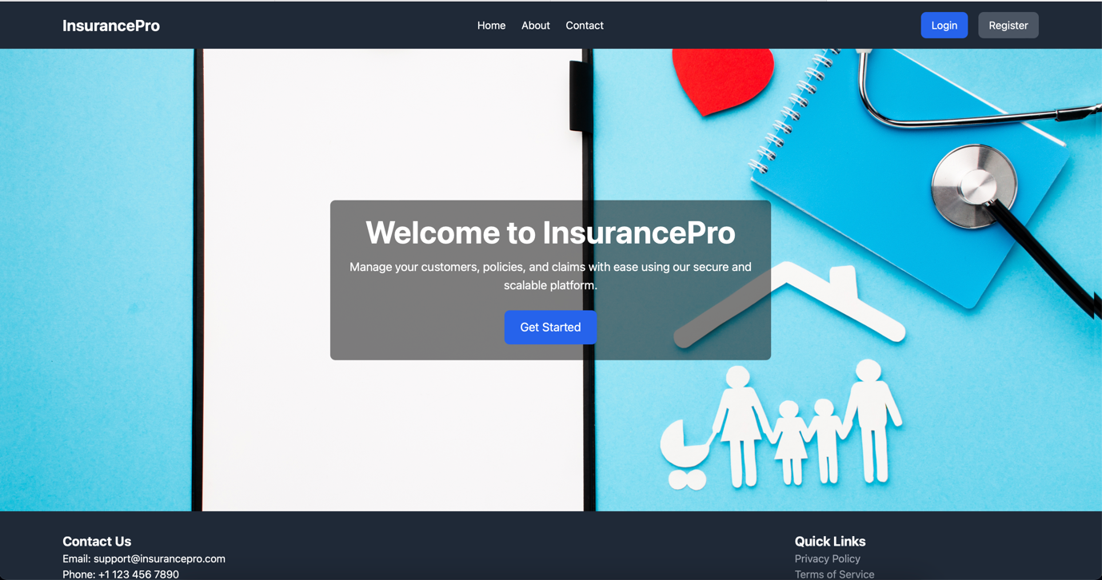

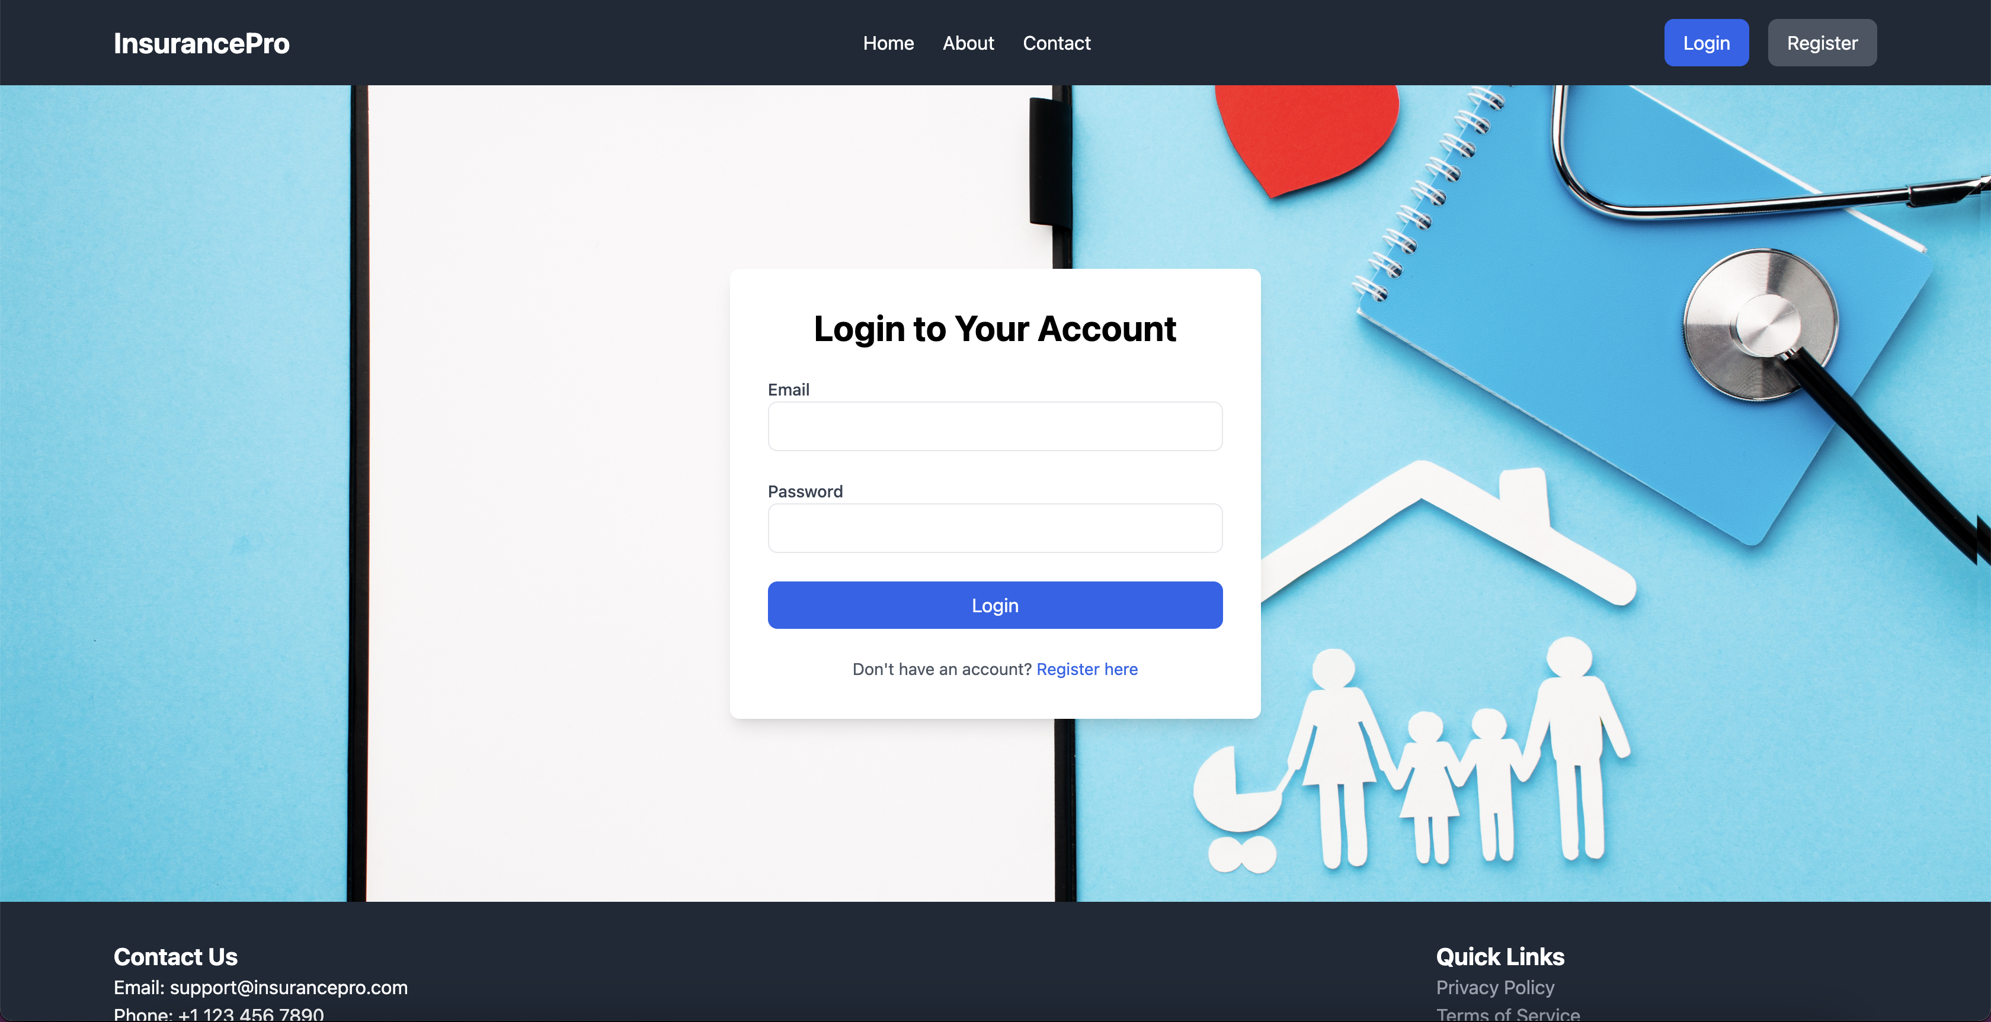

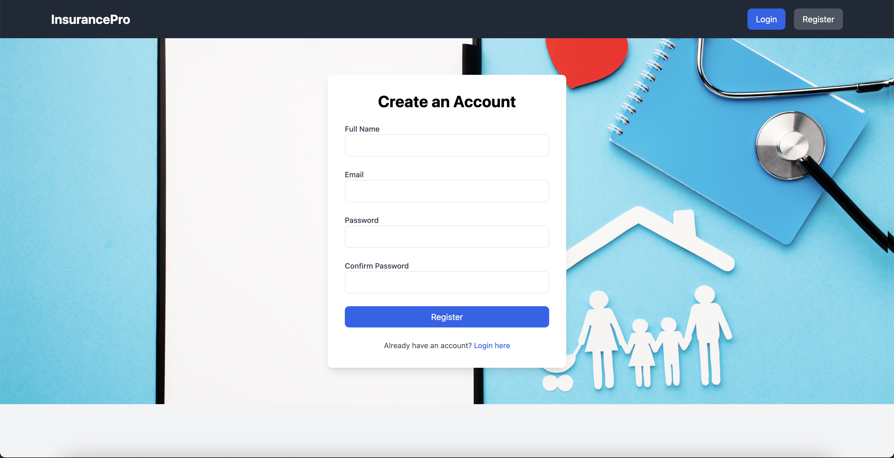

Broker Dashboard

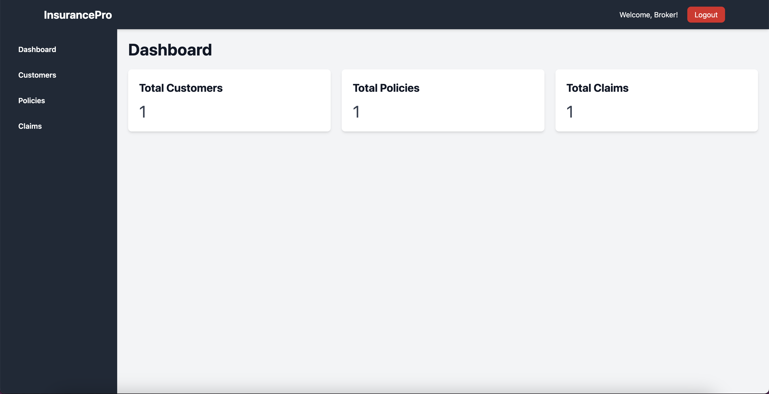

Customers Management

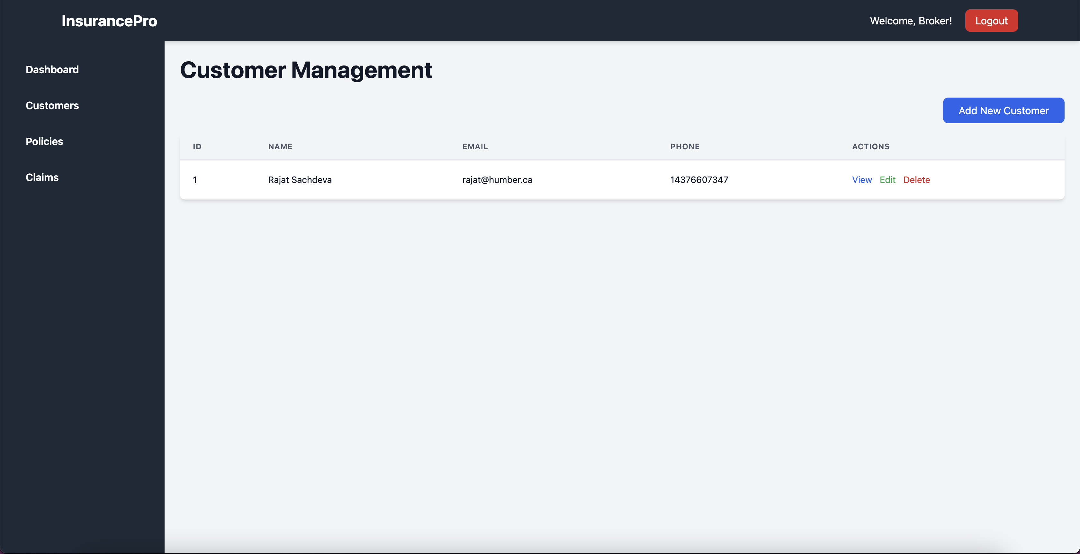

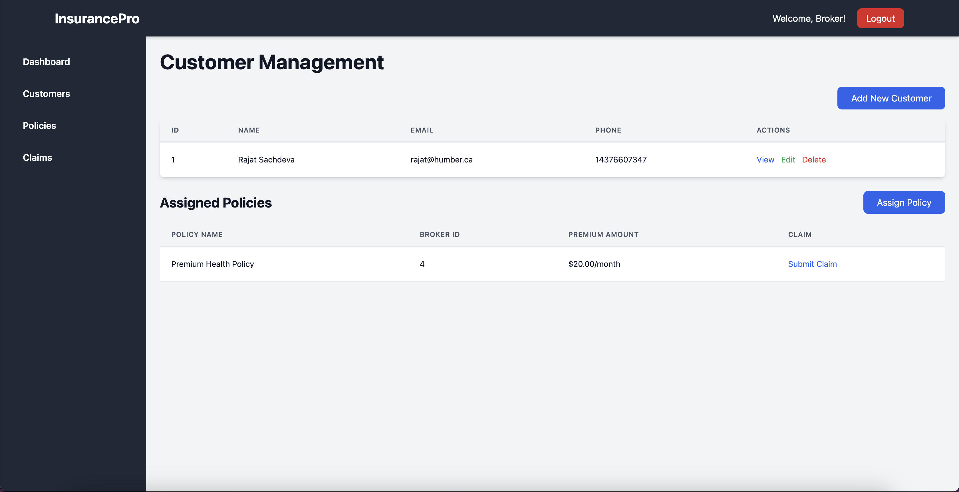

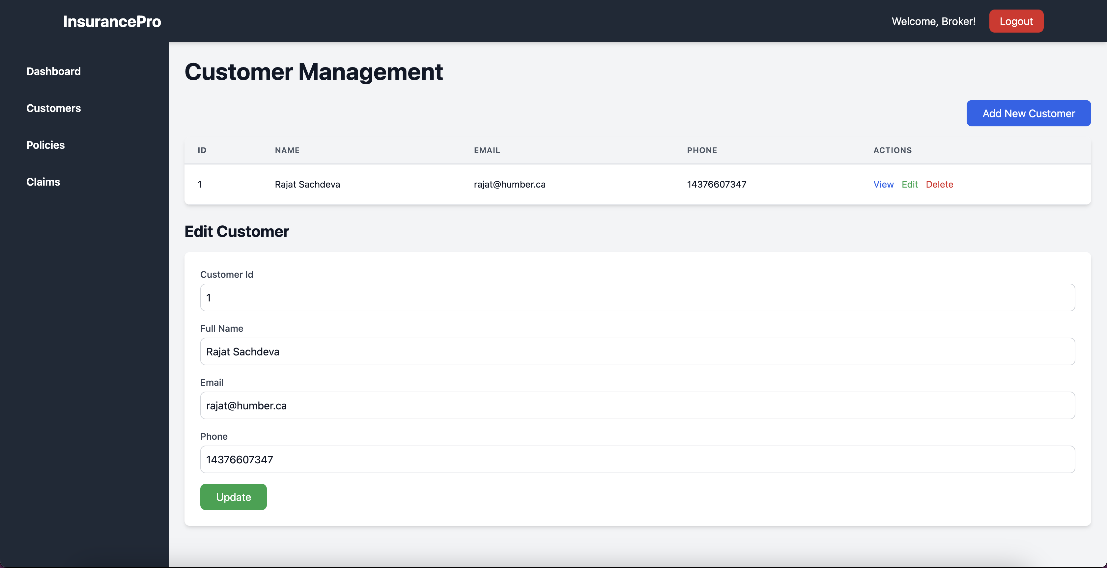

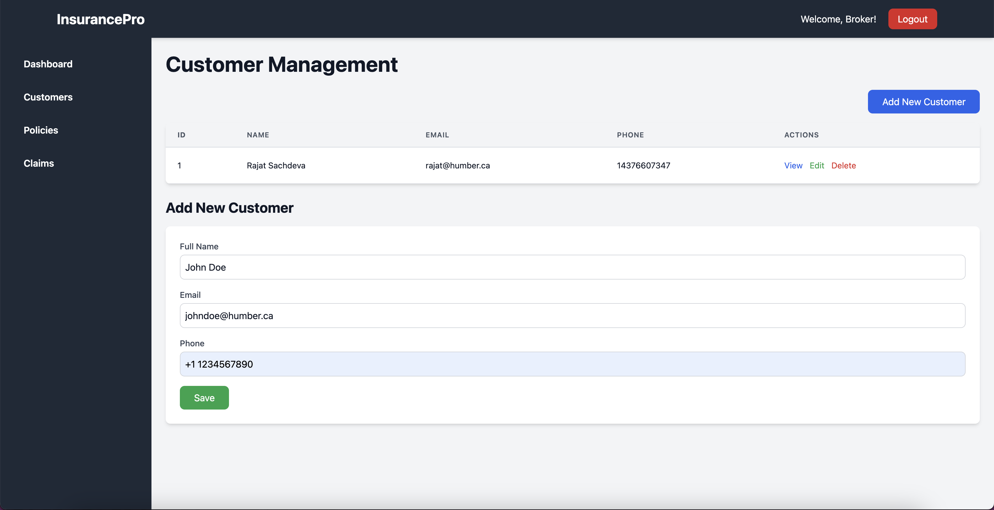

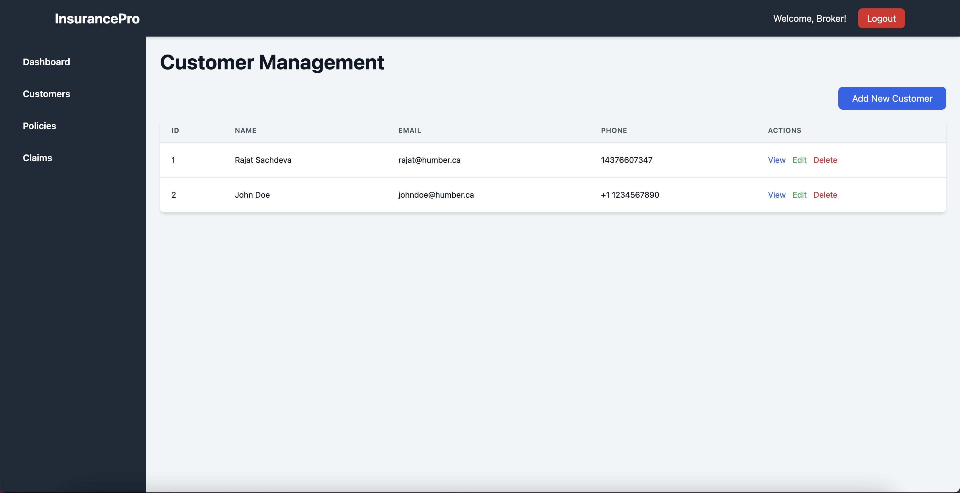

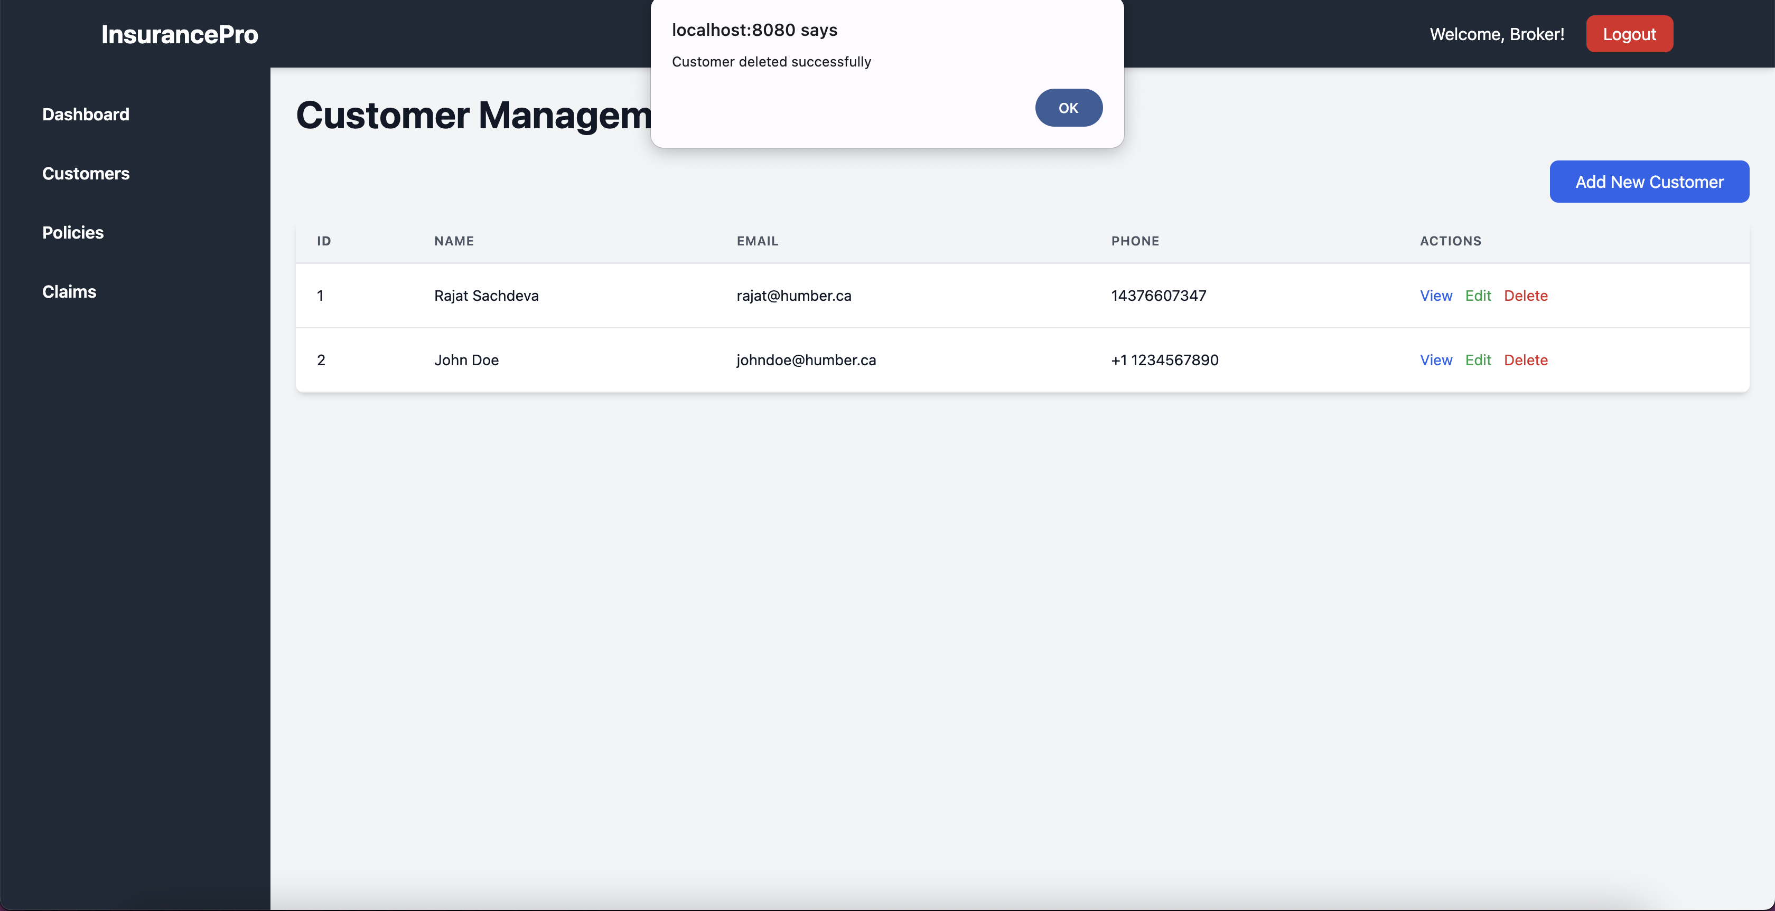



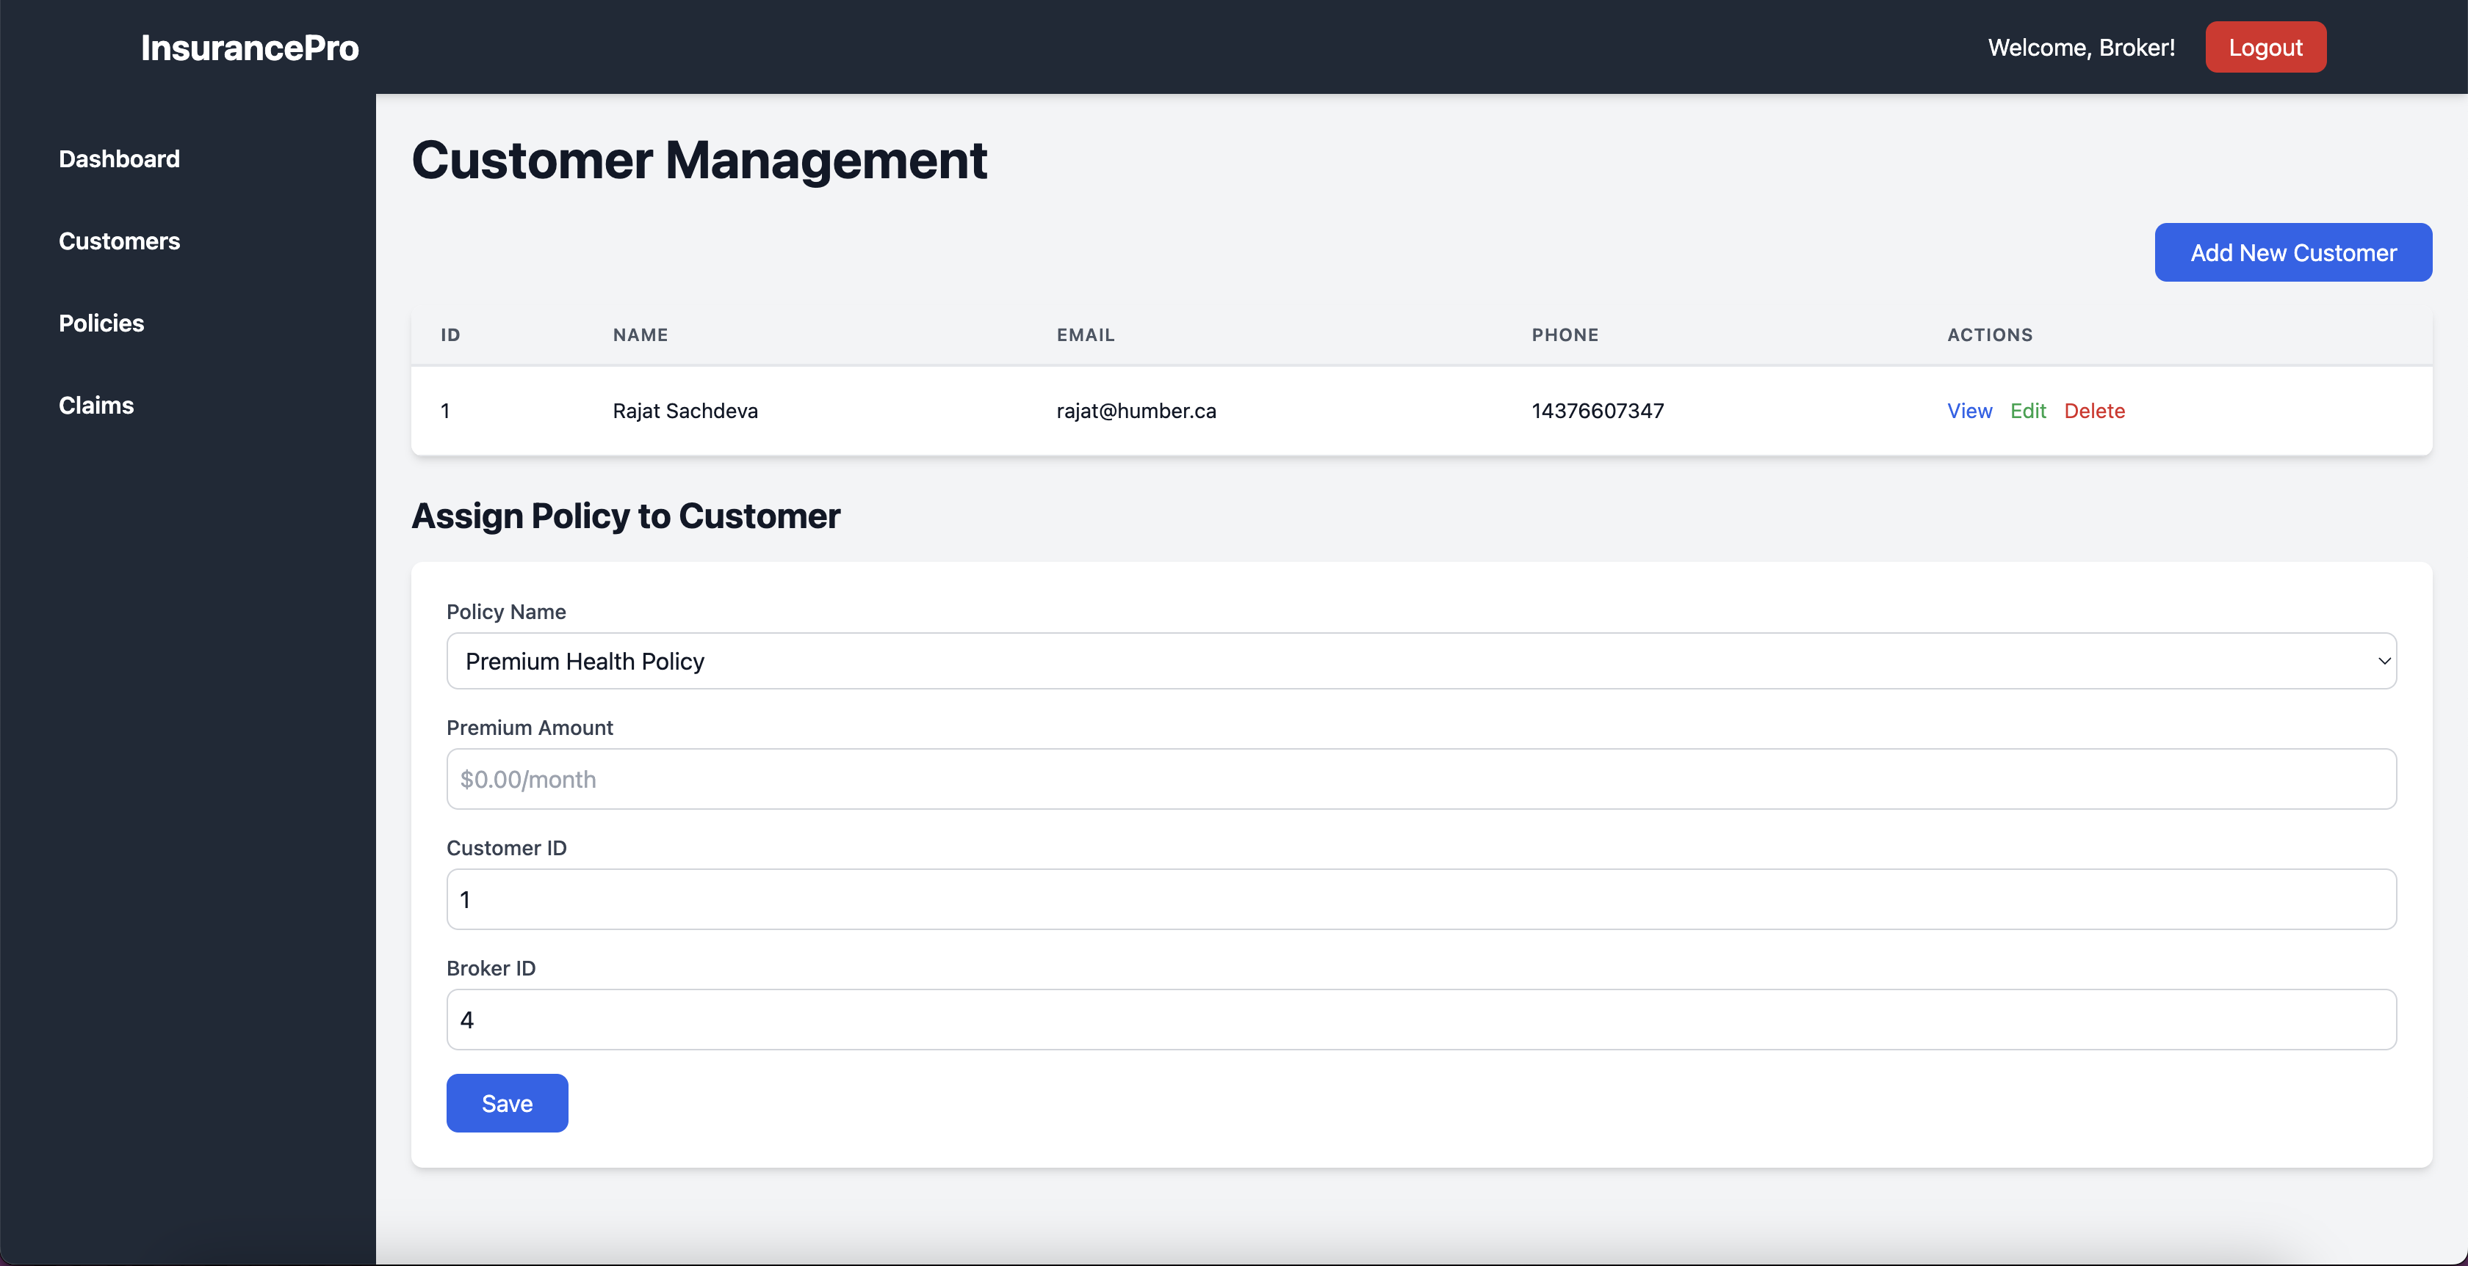

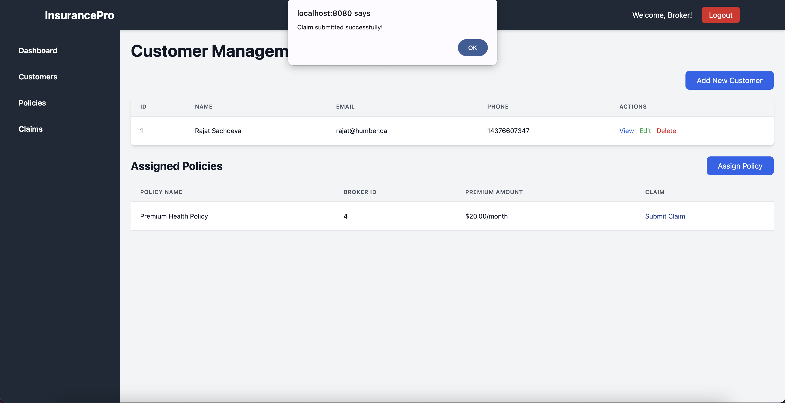

Policy Management

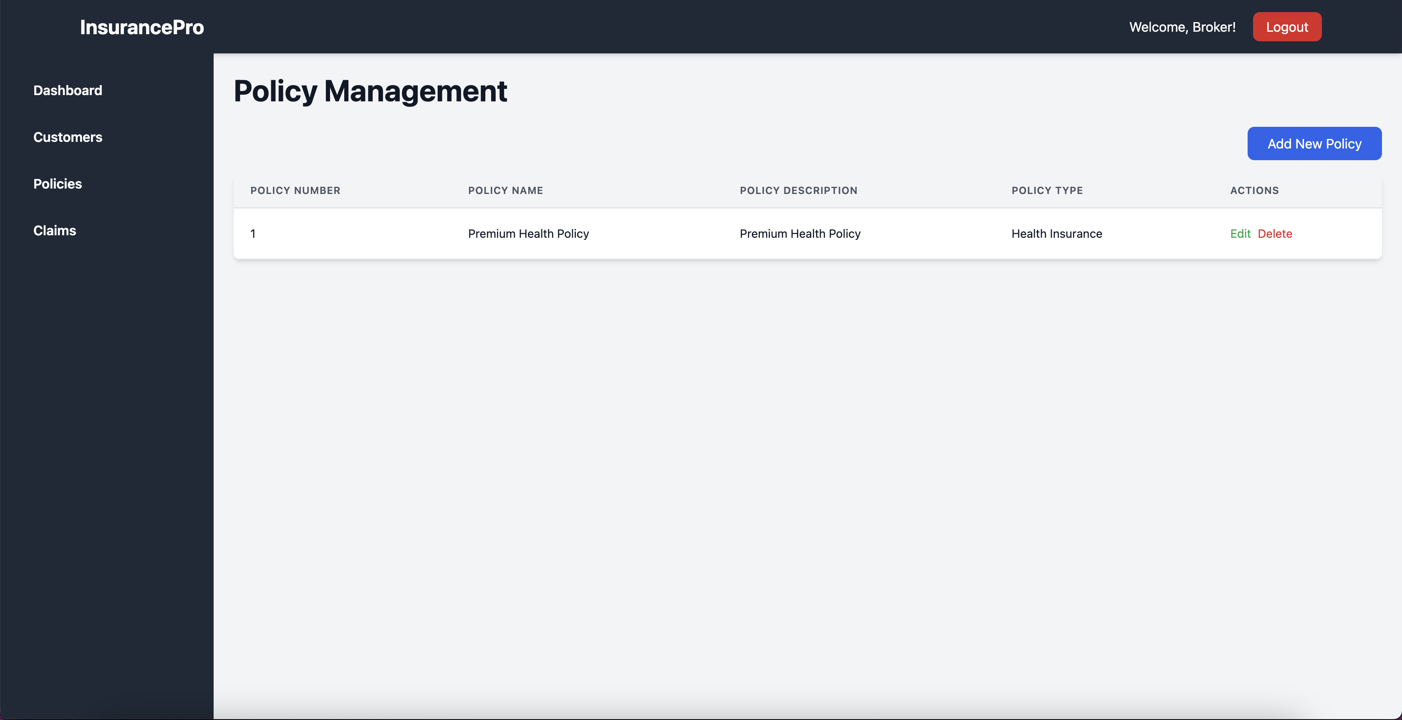

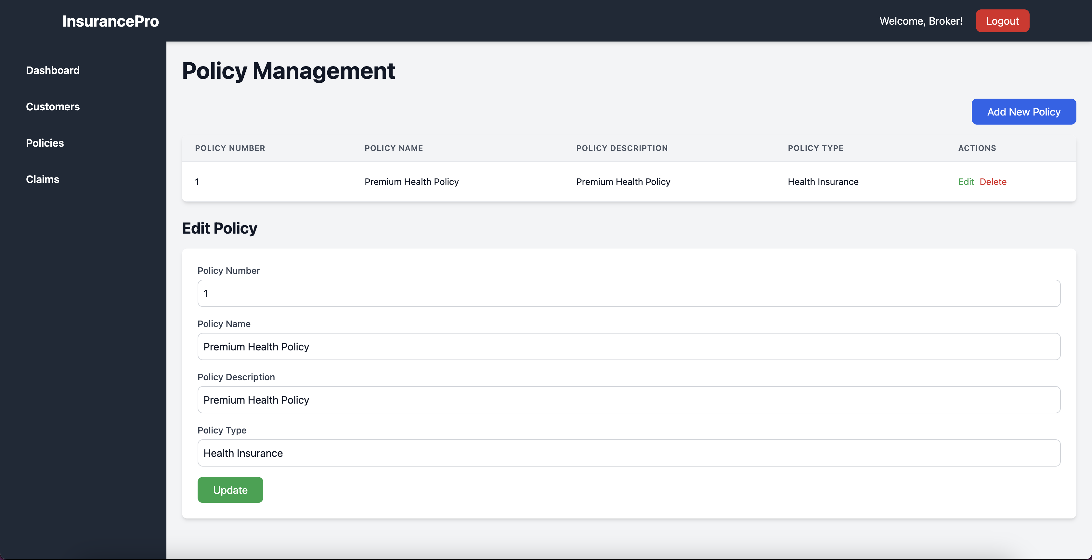

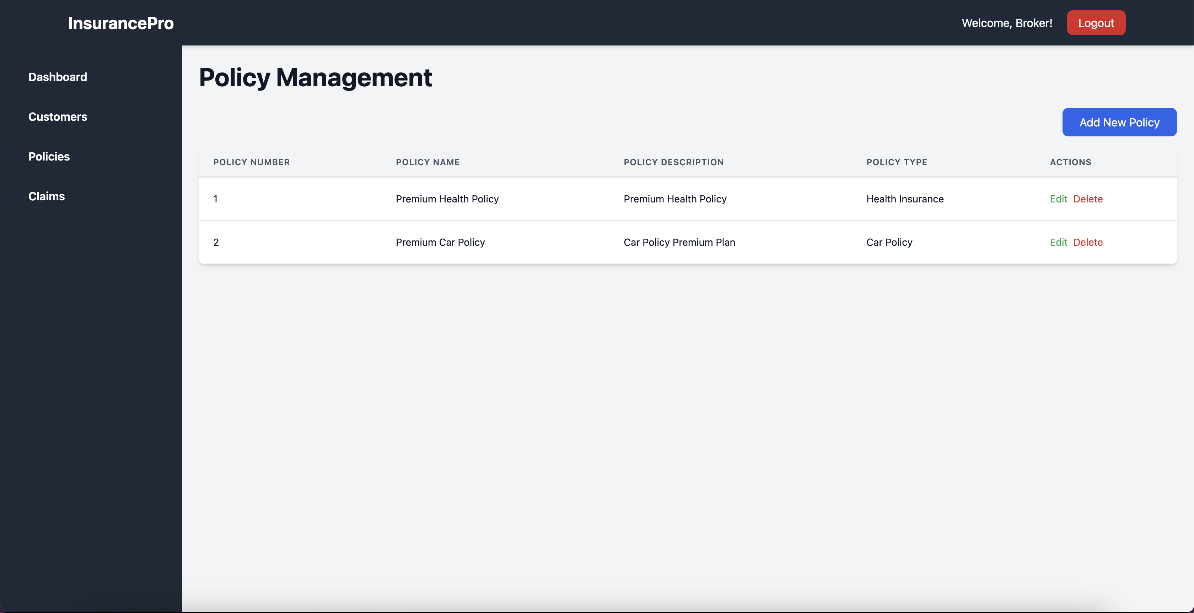

Claims Management

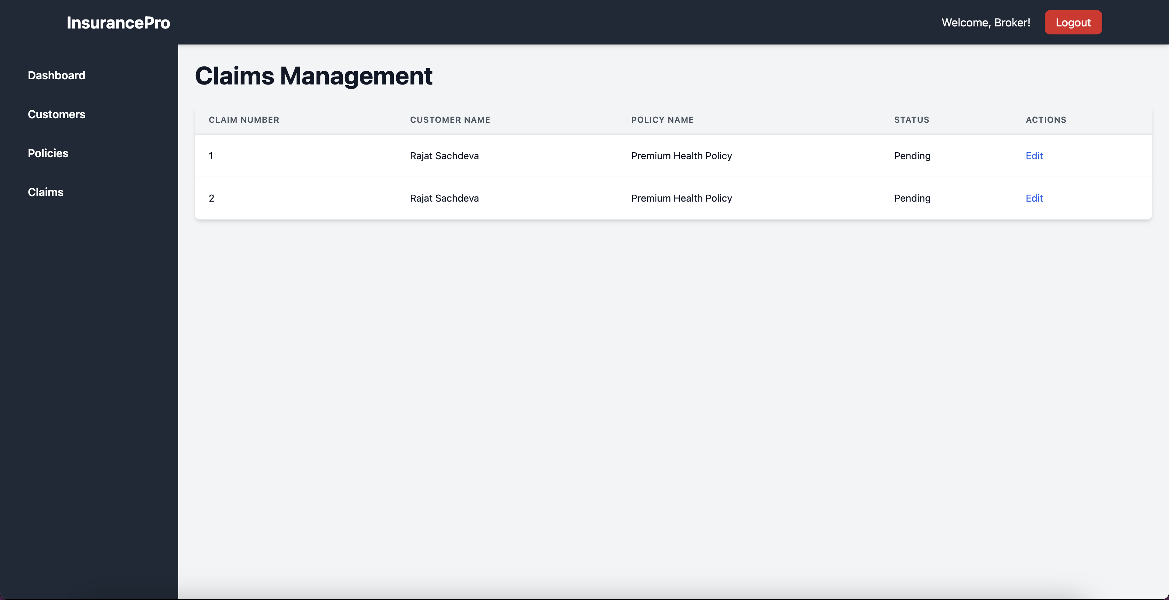

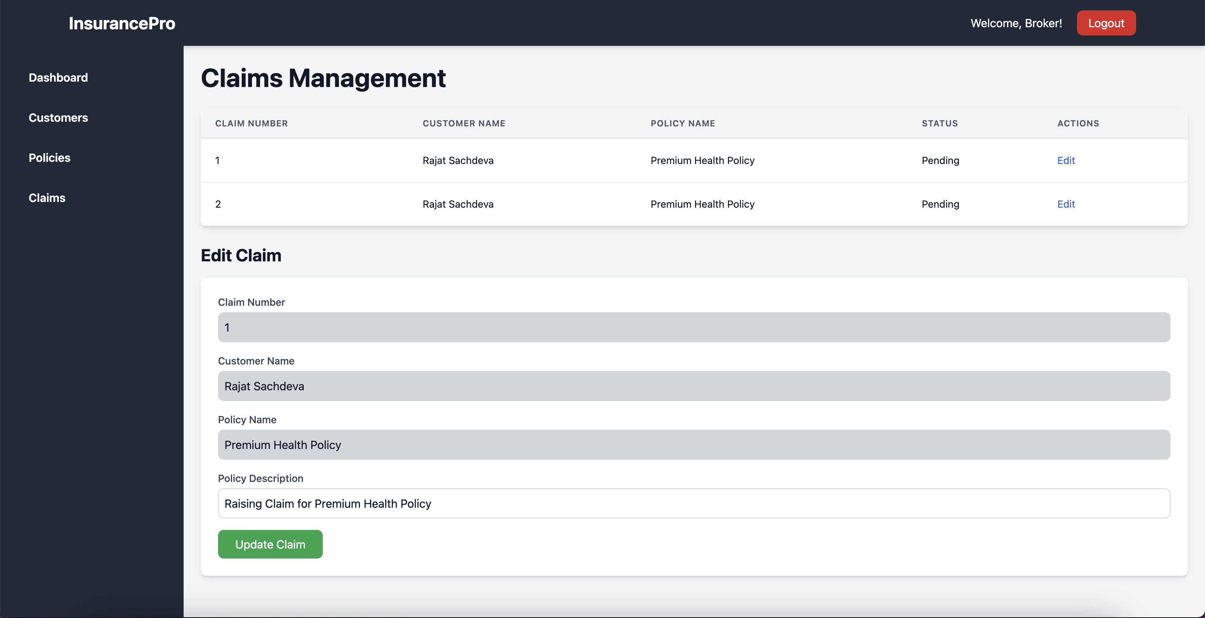

Reports Management

Implementation  
The Reporting Servlet aggregates data across multiple brokers to present insightful summaries:

* Customer Metrics: Total number of customers managed by each broker.
* Claims Metrics: Overall claim counts, approval and rejection rates.
* Policy Metrics: Total number of policies handled across the system.

User-Friendly Format  
The report output is formatted for clarity and easy interpretation, displayed in a summarized, tabular format.

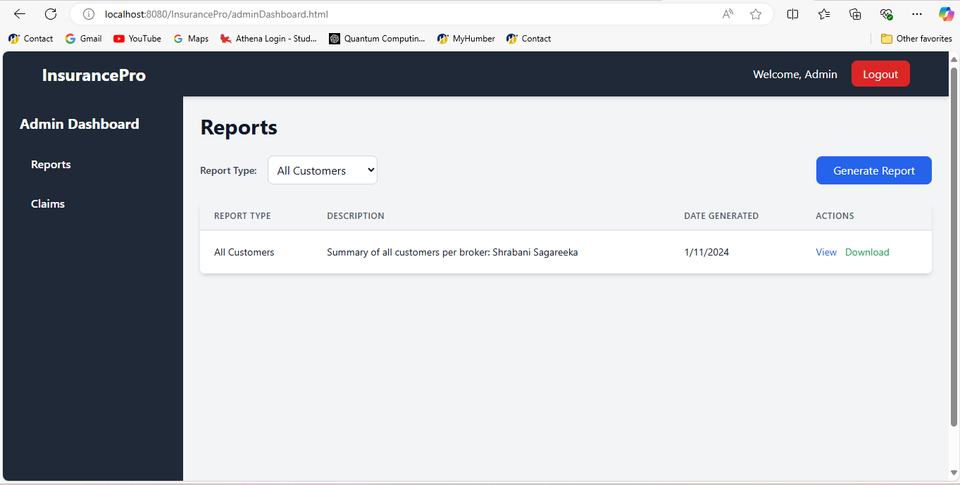

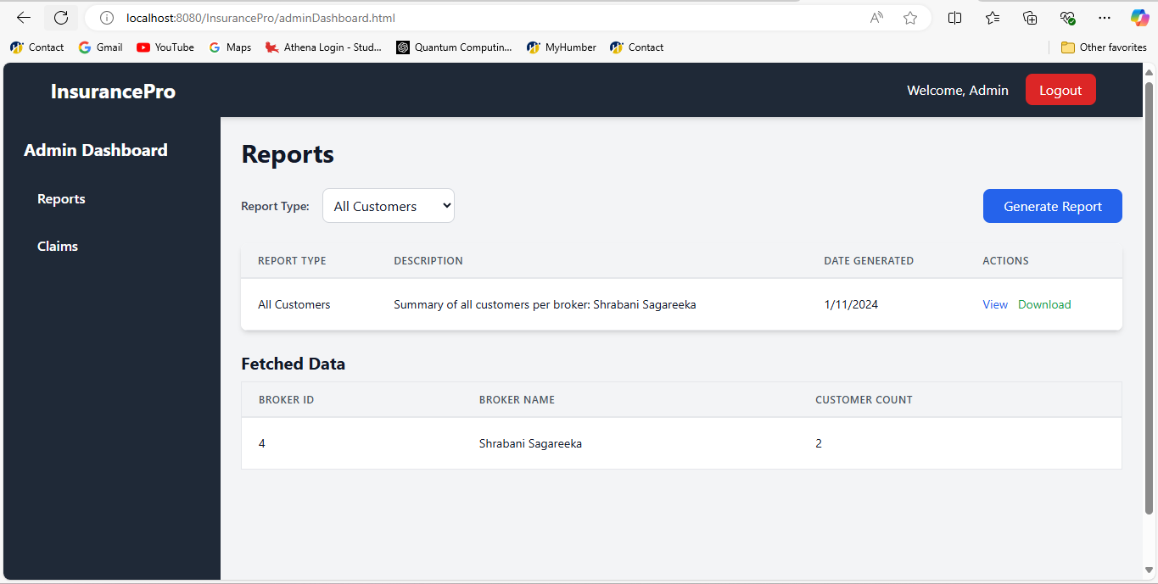

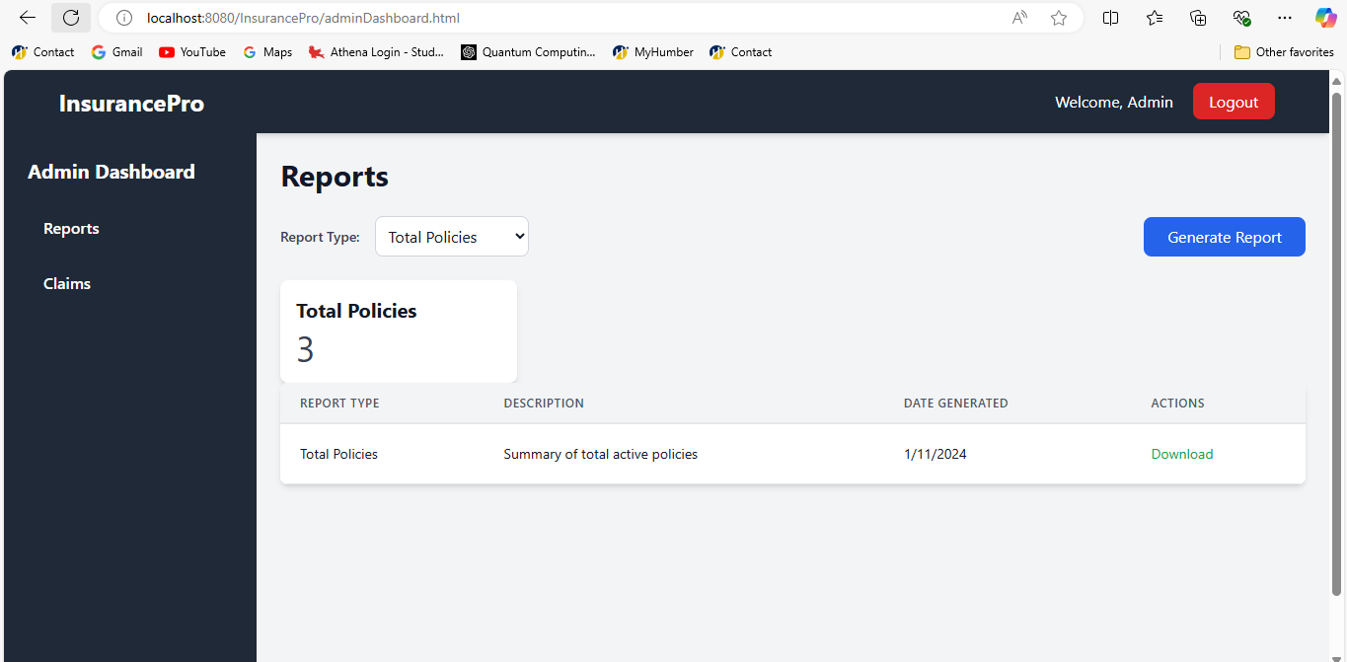

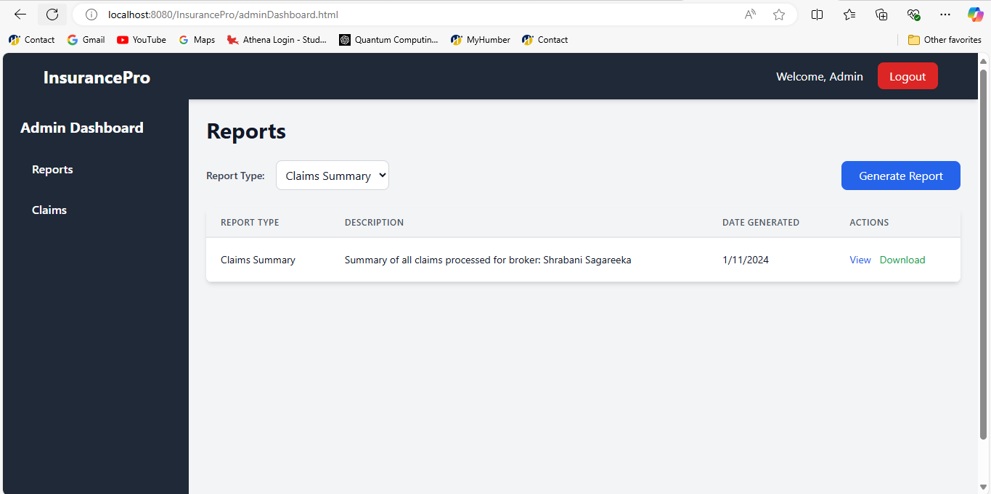

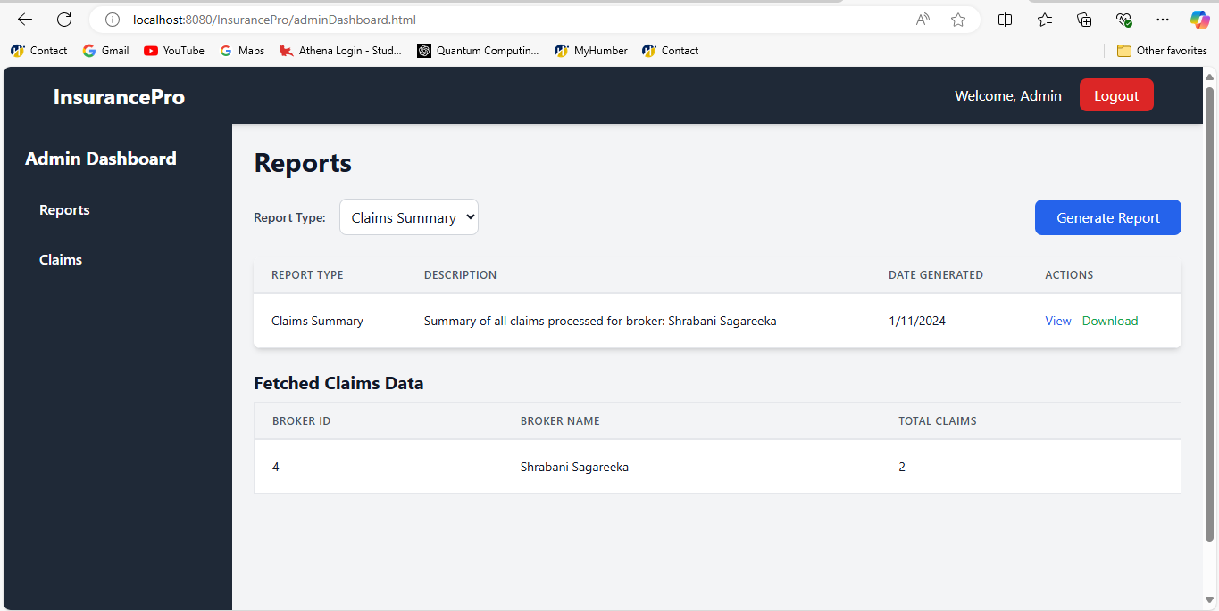

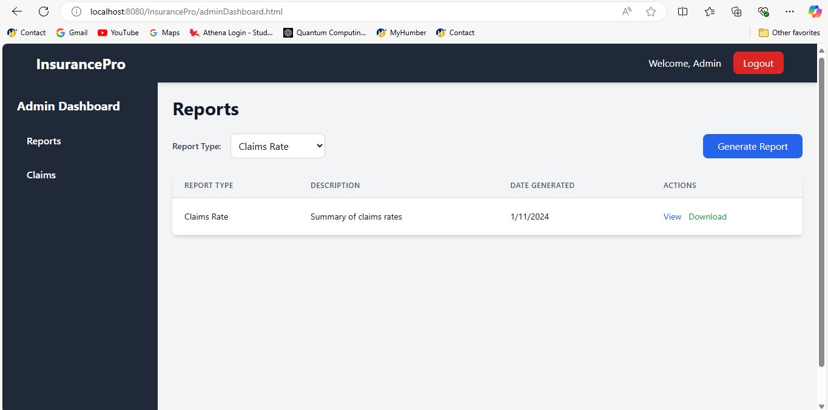

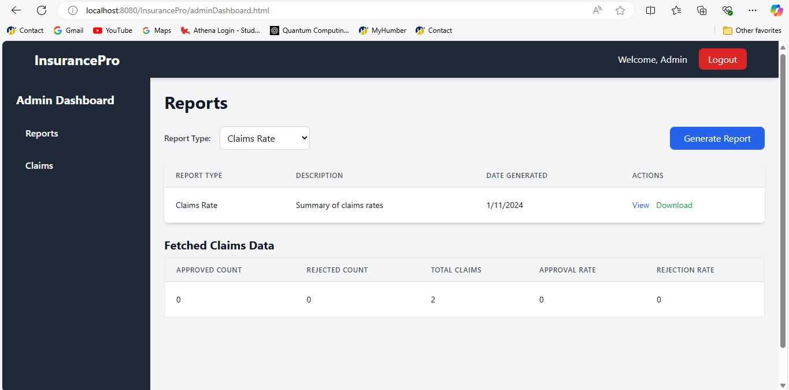

All Claims Management (Approve/Reject)

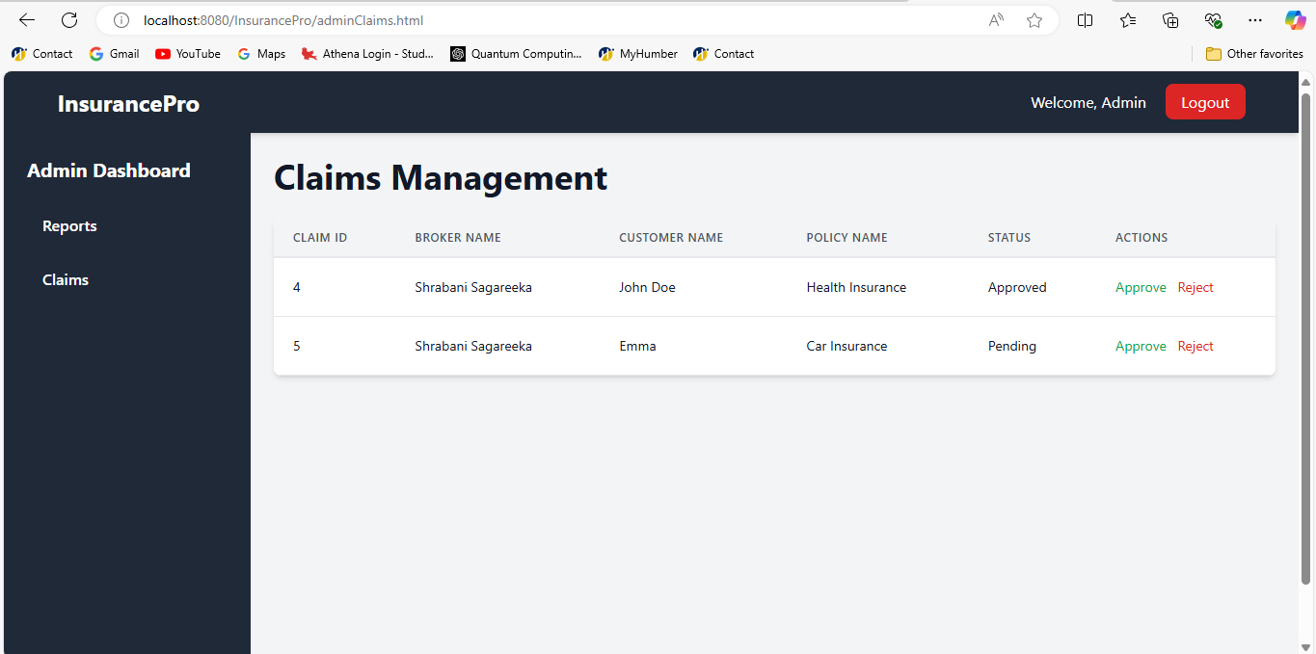

Thread-Safe Resource Management

Thread-Safety Mechanisms  
The IBMS employs thread-safety practices to handle concurrent broker access:

* Synchronized Blocks: Key sections in the repository methods are synchronized to prevent multiple threads from accessing shared resources simultaneously.

4. Servlet Configuration Using Deployment Descriptor

web.xml Configuration  
All servlet mappings are defined in the web.xml deployment descriptor for centralized configuration, maintaining a clear separation of setup parameters from code. Each servlet in the IBMS is mapped without annotations, as per project requirements, ensuring compatibility and standardized configuration practices.

Example Configuration in web.xml

<?xml version="1.0" encoding="UTF-8"?>

<web-app xmlns:xsi="http://www.w3.org/2001/XMLSchema-instance"

xmlns="https://jakarta.ee/xml/ns/jakartaee"

xsi:schemaLocation="https://jakarta.ee/xml/ns/jakartaee https://jakarta.ee/xml/ns/jakartaee/web-app_6_0.xsd"

version="6.0">

<context-param>

<param-name>jsonFilePath</param-name>

<param-value>/WEB-INF/data/customer.json</param-value>

</context-param>

<servlet>

<description></description>

<display-name>ViewCustomerServlet</display-name>

<servlet-name>ViewCustomerServlet</servlet-name>

<servlet-class>servlets.ViewCustomerServlet</servlet-class>

</servlet>

<servlet-mapping>

<servlet-name>ViewCustomerServlet</servlet-name>

<url-pattern>/V